Questions
Q1.
Figure 2 shows some of the income from different sources for four European football clubs in 2015.
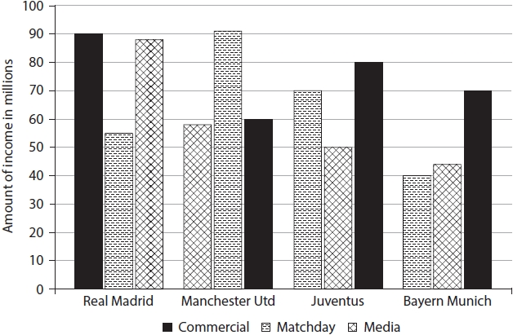
Figure 2
(a) Using the data in Figure 1 which club receives the highest matchday income?
(1)
A Real Madrid
B Manchester United
C Juventus
D Bayern Munich
(b) Using the data in Figure 1 which club receives the lowest income from media?
(1)
A Real Madrid
B Manchester United
C Juventus
D Bayern Munich

(Total for question = 6 marks)

Q2.
Figure 2 shows participation rates in four sports between 2009 and 2014.
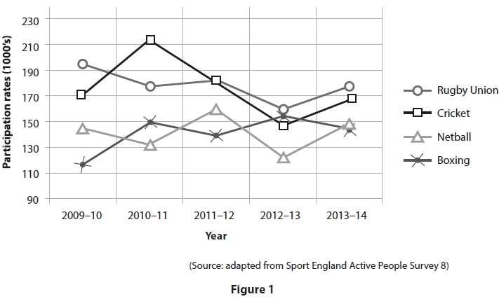
(a) Using Figure 1, identify the sport with the highest participation rate in 2013–14.
(1)
A Boxing
B Cricket
C Netball
D Rugby Union
(b) Using Figure 1, identify the sport with the greatest increase in participation rate from 2009–10 to 2013–14.
(1)
A Boxing
B Cricket
C Netball
D Rugby Union

(Total for question = 6 marks)

Q3.
Figures 2a and 2b show childhood obesity trends for boys and girls from 1994 to 2014.
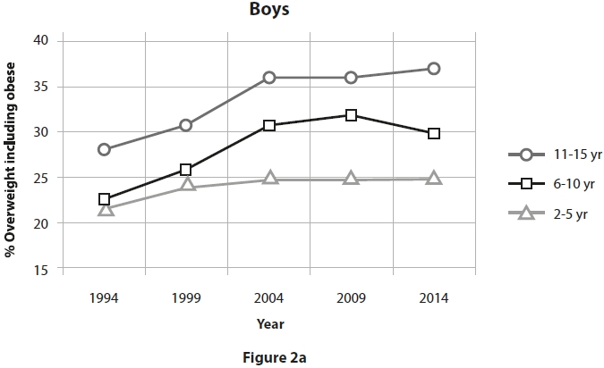
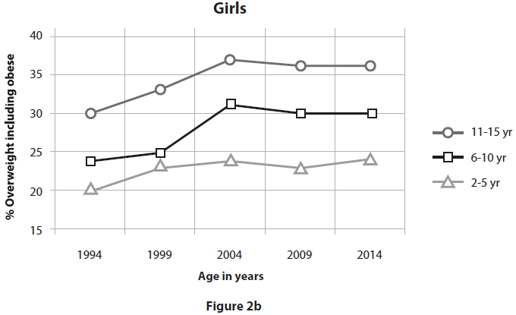
(a) Analyse the data in Figures 2a and 2b to determine the changing patterns in obesity levels from 1994 to 2014 based on:

• age
• gender
Age
(2)
.............................................................................................................................................
.............................................................................................................................................
.............................................................................................................................................
Gender
(2)
.............................................................................................................................................
.............................................................................................................................................
.............................................................................................................................................
(b) Using the data in Figure 2a, predict the most likely trend in obesity levels for 11-15 year-old boys in 2015.
(1)
.............................................................................................................................................
.............................................................................................................................................

(Total for question = 5 marks)

Q4.
Figure 7 shows Olympic doping cases by sport from 1968 to 2010.
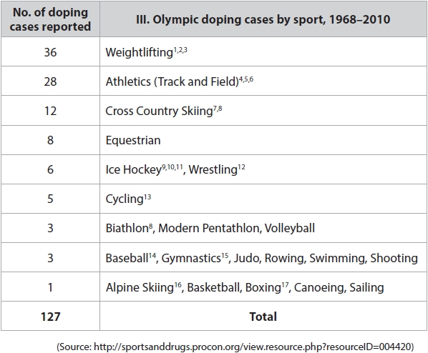
Figure 7
Using Figure 7:
(a) Identify the activity with the greatest number of reported doping cases.
(1)
.............................................................................................................................................
(b) State the most likely type of performance-enhancing drug taken by the performers in the activity you identified in (a).
(1)
.............................................................................................................................................
Figure 8 shows the number of doping tests carried out in summer and winter Olympic Games.
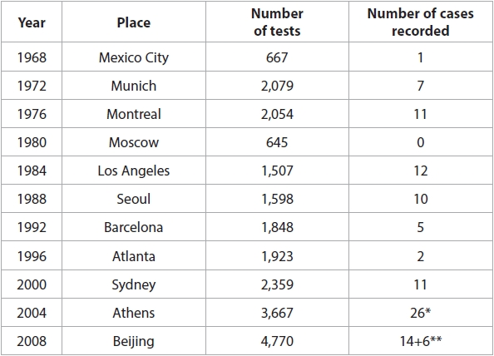
Summer games
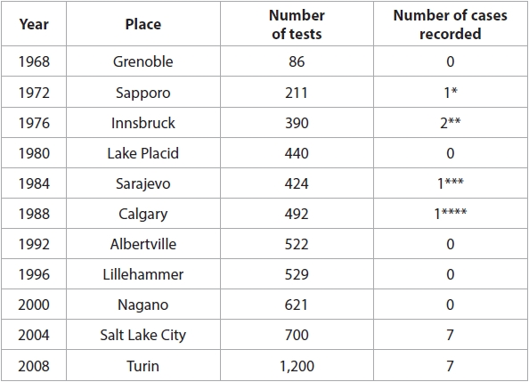
Winter games
(Source: http://sportsanddrugs.procon.org/sourcefiles/IOCFactsheet2010.pdf)
Figure 8
(c) Analyse the data in Figure 8 to determine:

• The trend in number of tests administered at the Olympic Games.
(1)
.............................................................................................................................................

• A difference in testing data between the summer and winter games
(1)
.............................................................................................................................................

(Total for question = 4 marks)

Q5.
Heart rate is measured in beats per minute (bpm).
Table 3 shows a performer's heart rate at three different times during an exercise session.
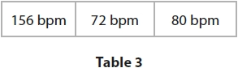
(a) Identify from Table 3 the heart rate values recorded just before exercise starts and during recovery.
(2)
.............................................................................................................................................
.............................................................................................................................................
.............................................................................................................................................
.............................................................................................................................................
(b) Give reasons for your answers.
(2)
.............................................................................................................................................
.............................................................................................................................................
.............................................................................................................................................
.............................................................................................................................................
.............................................................................................................................................

(Total for question = 4 marks)

Mark Scheme
Q1.

Q2.

Q3.
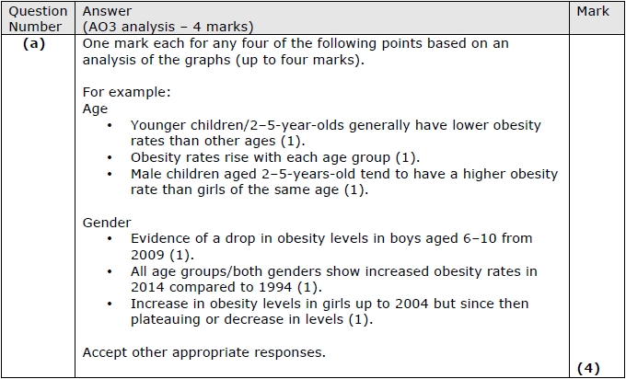
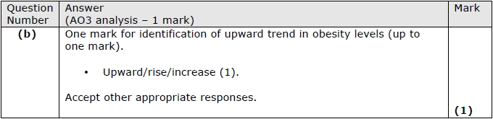

Q4.
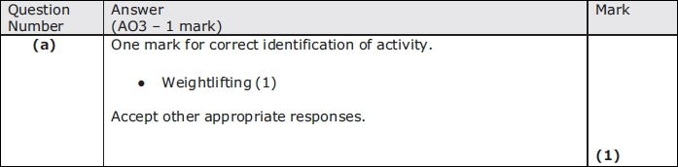
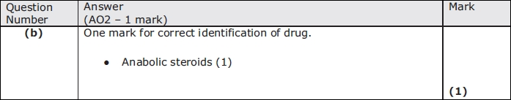
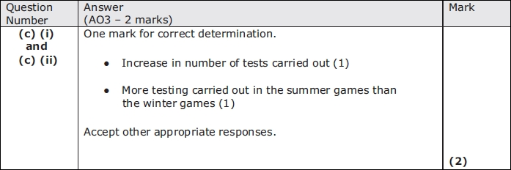

Q5.
